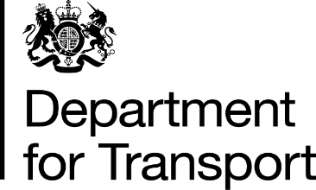

Department for Transport
3rd Floor,
One Priory Square,
Hastings,
TN34 1EA

Tel: 0300 330 3000

Web Site: www.gov.uk/dft
Email: cbssg@dft.gov.uk

XX XXXX 2021

To [bus operator]

via email

Dear [operator],

School Services – Home to school – BSOG Eligibility

As part of the ongoing review of Bus Service Operator Grant (BSOG) due to COVID-19, the Department is aware that conflicting messages have been provided in respect of the eligibility criteria for the home to school closed services.

Previous BSOG eligibility for school services was agreed in September 2018 and these rules were applied to services operated as part of the home to school service initiative. As a result, the kilometres claimed for these services were removed from BSOG claims resulting in a reduced payment of BSOG.

The Department recognises that in some instances where an operator has been unable to secure funding from their local transport authority, provided by the Department for Education or through the CBSSG scheme, this has resulted in a shortfall. In order to address the departments commitment to a “no better, no worse” approach to BSOG payments on eligible services, we are extending payment of BSOG as an exception to cover the entirety of these services including the home to school element.

This will only apply to commercial services and only from 1st September 2020. This funding will continue until advised otherwise pending any future changes to COVID-related funding supporting the industry.

The Department requests that all operators complete the attached survey to assess their eligibility for this funding. This survey will need to be completed by 26 March 2021 in order for the appropriate assessment to be undertaken before claims are paid.

You may receive a request to complete the survey as a recipient of the BSOG and CBSSG schemes. If this is the case the survey only needs to be completed once as the information will be used for both schemes.

This process can also be used for retrospective claims relating to the period from 01 September 2020 when these change to services may have come into force to support the Home to School approach for operators who have already submitted BSOG claims, and also for any future claims. Any adjustments to past claims will only apply to the certified claims that have been submitted. Calculations will be based on the kilometres per litre (kpl) factor as provided from the certified claims

Given the short-term nature of the home to school initiative we will not be accepting adjustments to any current or future estimated claims.

Further guidance will be issued in due course advising operators on the process for claiming these services retrospectively for claims already submitted. Current claims should now reflect the total kms, including the aspect of the route that is closed specifically for the home to school element.

Yours sincerely,

BSOG Team
Local Transport COVID-19 Response Division, Department for Transport

